2019-2020

Cybersecurity Project Documentation

Four in a Row

Nicola Barsanti Gianluca Tumminelli

Contents

**Software Description** **3**

**Service Architecture** **4**

Network Design 4

Security Design 4

**Protocol Architecture** **5**

The cheater problem 6

**Protocol Analysis** **8**

Certificate Protocol 9

Login Protocol 10

Logout Protocol 12

User List Protocol 13

Rank List Protocol 14

Challenge Protocol 15

Withdraw Protocol 18

Move Protocol 18

Chat Protocol 20

Disconnect Protocol 21

**Software Architecture** **22**

Server 23

UML Diagram 24

**User Manual** 25

Software Description

# This paper will document the development of the **Four In A Row Online** game, an online multiplayer video game used through a prompt interface.

# Registered users of the service can access by providing a valid username and password through the ***Login Page***.

# Once connected to the service, from the ***Main Page****,* they will be able to see all active users, a ranking of player results and challenge requests received from other players. They will also be able to accept one of the challenges received or by choosing a user request a challenge against him.

# The game developed is the Four In A Row classes and it will be played in the ***Game Page***, the game is based on a 6x7 grid in which it is possible in turn to insert a token. The first player who manages to insert 4 tokens in a row wins the game, vice versa if the grid is complete without any winner it ends with a tie.

# The confidential information of the users must be protected from be stolen by malicious attackers. Each message authenticity must be proved and the service must be robust to malicious and non-malicious threads.

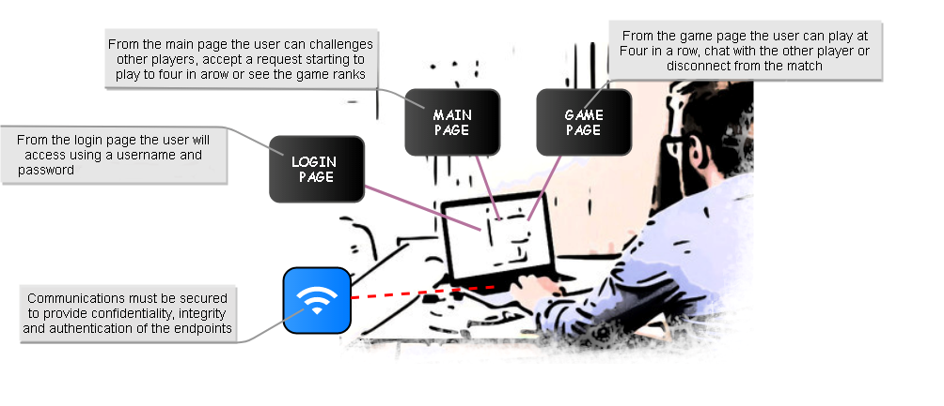

**Network Design**

Service Architecture

# The application is delivered by an hybrid communication approach. Each user will have a p2p communication implemented in UDP, to play a match with other players and client-server communication implemented in TCP, to log into the service and perform all the available operations.

**Security Design**

# Each communication channel will be protected by an AES-256 session key which will be used to encrypt confidential information and authenticate the messages. All the users have also a RSA key-pair to authenticate themselves to the service and other users. To guarantee the freshness of the messages each message(except the first one to request the server PEM certificate) will have a fresh nonce authorized by the server and which will be incremented after every completed request to guarantee protection from reply-attack.

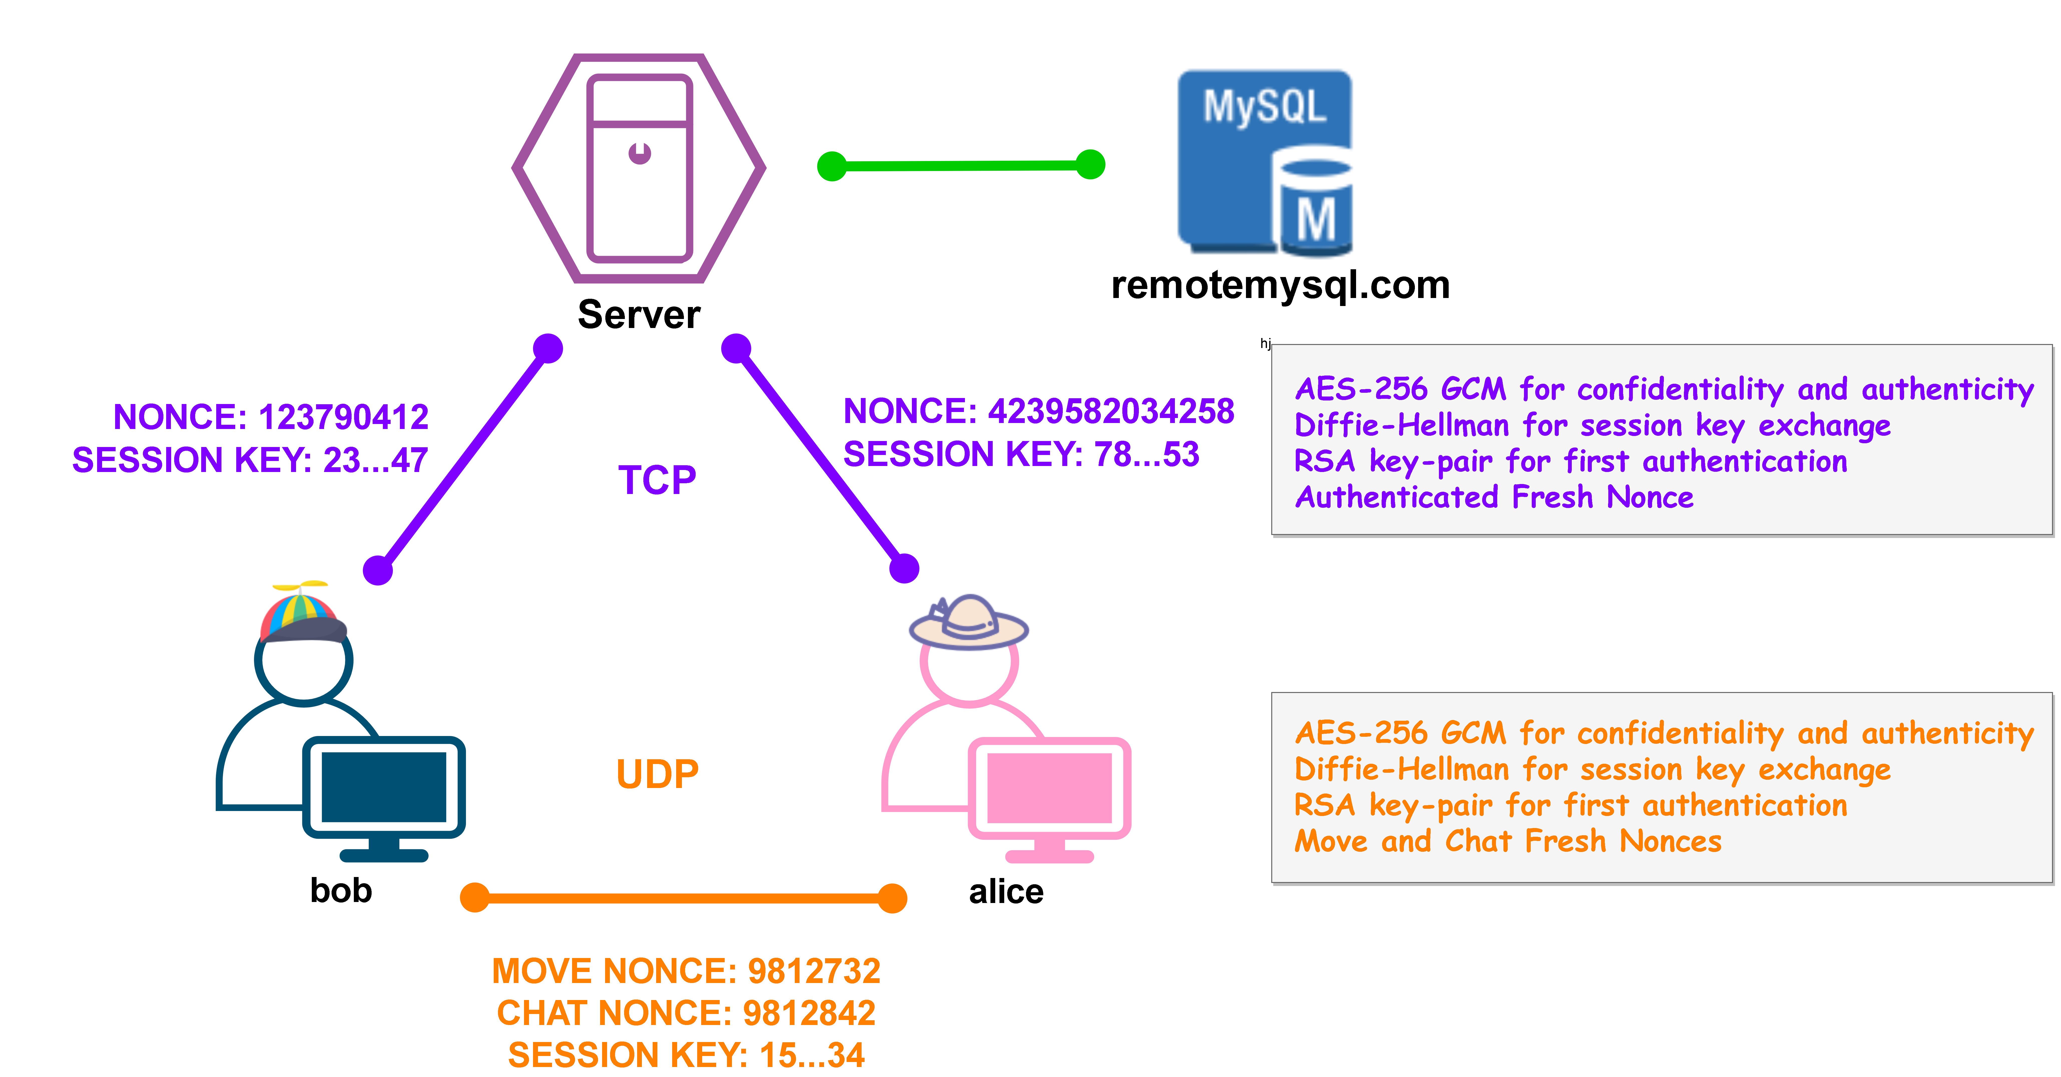

Protocol Architecture

# The service is based on a mono-threaded server in which by a shrewd implementation we gives the impression of a multi-threaded one. In particular the communication exchanges must be designed to be in a request-response way with no dead-time spent by the server to attempt some responses to complete an interaction(otherwise meanwhile the server is waiting all the users will wait too generating delays in the requests commitment). To perform its operation we have designed 11 possible type of requests to the server:

* **CERTIFICATE**: *request the server certificate and an authorized nonce*
* **KEY EXCHANGE**: *exchange an AES-256 key using Diffie-Hellman algorithm*
* **LOGIN**: *access the service giving a valid username and password*
* **LOGOUT**: *logout from the service*
* **USER LIST**: *request a list of the available users of the service*
* **RANK LIST**: *request a list of the game’ranks*
* **CHALLENGE**: *match an available user*
* **ACCEPT**: *accept a received user challenge*
* **REJECT**: *reject a received user challenge*
* **GAME PARAM:** *exchange user’parameters needed to start a match*
* **DISCONNECT**: *leave a match*

# And 3 possible types of message that can be exchanged by the users during the playing of a match:

* **KEY** **EXCHANGE**: *exchange an AES-256 key using Diffie-Hellman algorithm*
* **MOVE**: *send the next game move of the user*
* **CHAT**: *send a message from the users during a match*

# During the game the users use a different channel that hides the information about the progress of the challenge from the server. With this configuration, users could cheat by invalidating the results contained in the ranking. To prevent this we need to provide the server with some form of control and for this reason we have introduced the **GAME** message. When a player makes a move, he adds a replica signed by his private RSA key to the **MOVE** message. The receiving player, having checked the consistency of the move made and the one inserted in the attached copy, will sign it and send it to the server which will then be able to verify the progress of the game. The reason for the second signature is to prevent a second form of attack by the cheaters. Our policy is very bad with cheaters, if a player is suspected of having modified a message voluntarily he is punished by automatically making him lose the game. We must therefore prevent a player from impersonating the opponent by voluntarily sending us invalid information to make him lose, this is the reason why a form of authentication is required for both players.

**The cheater problem**

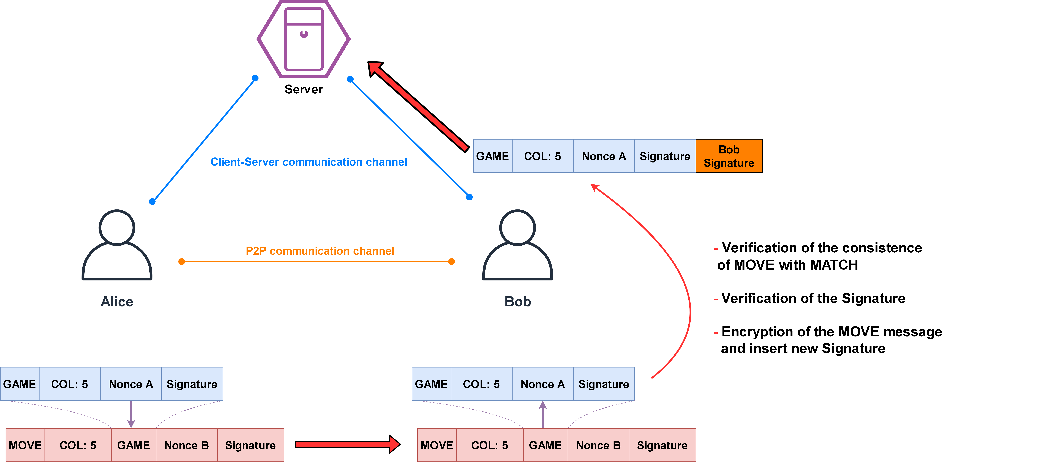

Protocol Analysis

# In the following section there will be described in detail the exchange of the application messages and their structure. We have designed four extra postulates to manage particular situations not covered by the base postulates. During all the analysis with the symbol H we mean an HMAC obtained by some message fields specified with the subscript notation. During the ban analysis we will consider it equivalent to the encryption of all the included fields.

**Signature Postulate**

To simplify the BAN Analysis we have made a simple postulate to link the presence of a signature of all the fields of the message to their trustability.

**Diffie-Hellman Postulates**

We need a postulate to link the possession of two Diffie-Hellman parameters to the generation of a shared session key. To simplify the analysis we consider the message and the key the two components to be shared by the two parts independently from what they really are(client-server, client-client)

We need a postulate to link the freshness of the Diffie-Hellman parameters to the freshness of the shared session key

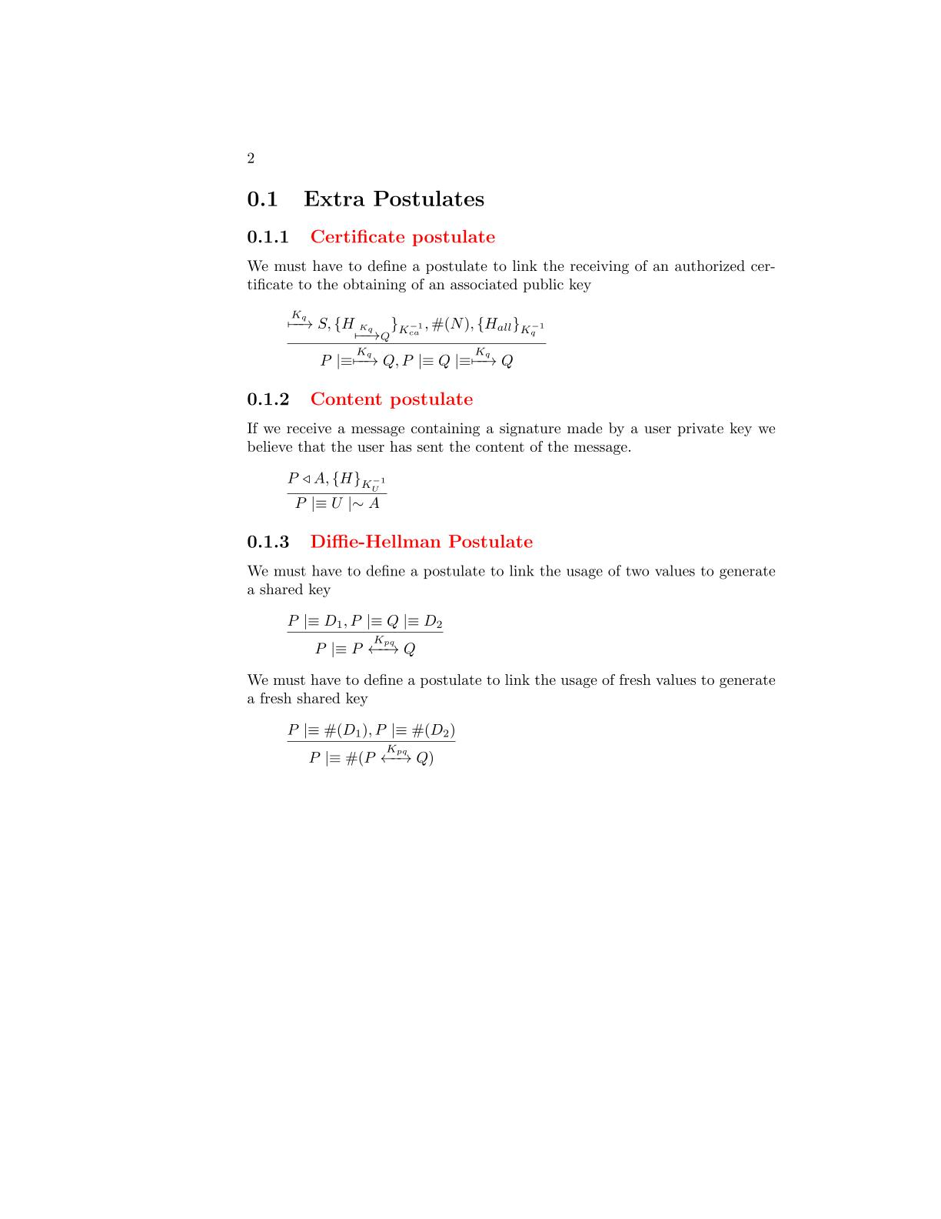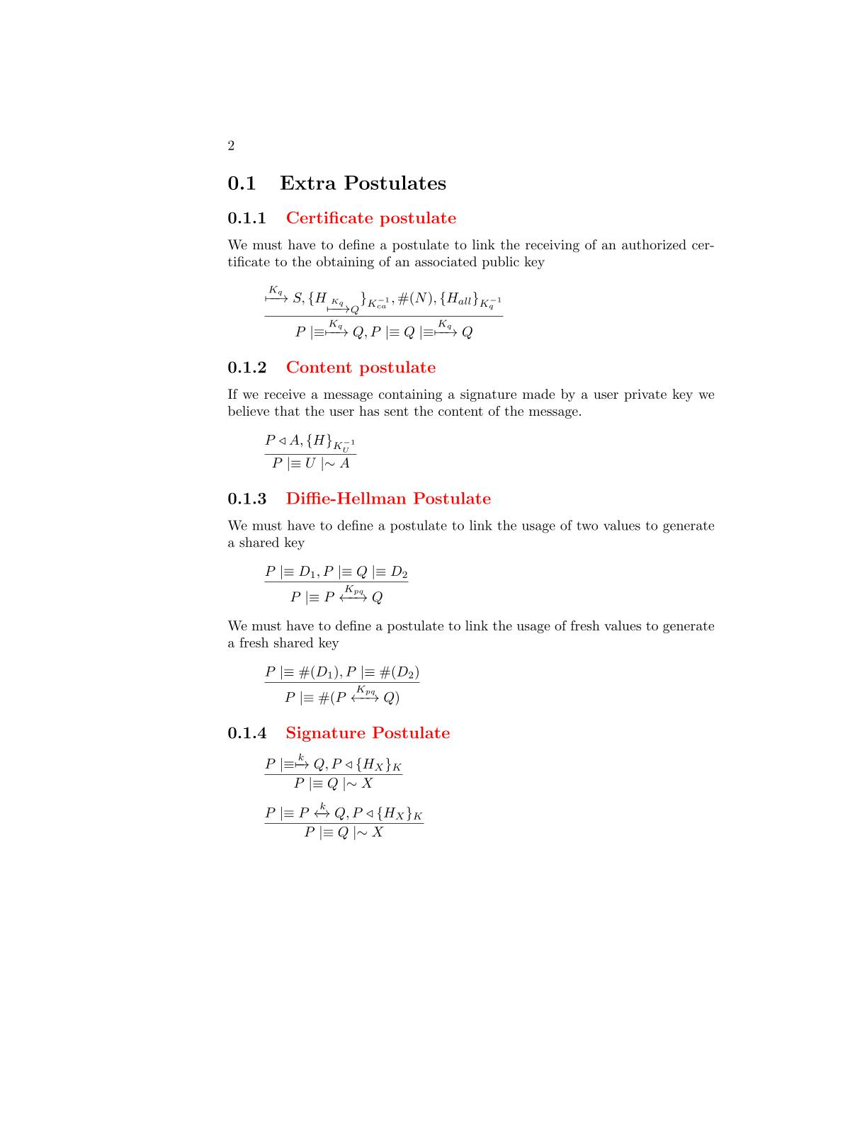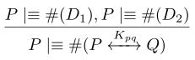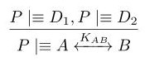

**Certificate Postulate**

We need a postulate to link the receive of a server authorized certificate to the obtaining of a valid user public key.

**Certificate Protocol**

# The protocol is used during the client initialization to obtain the server certificate and an authenticated fresh nonce. It is designed to be the first protocol which the clients will execute, as a result of that we have decided to use it also to give the first nonce that the clients will use to generate verifiable fresh information to perform their requests. In this way we prevent randomly chosen nonces susceptible to be a vulnerability for replay attack. The message doesn’t require any kind of protection, this is the reason why all the fields are not encrypted and no signature is applied on the request message.

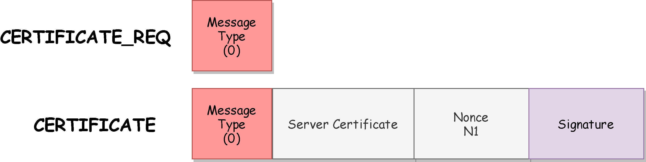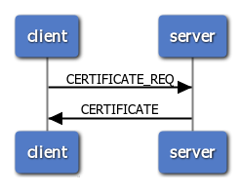

**BAN Logic Analysis**

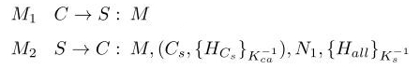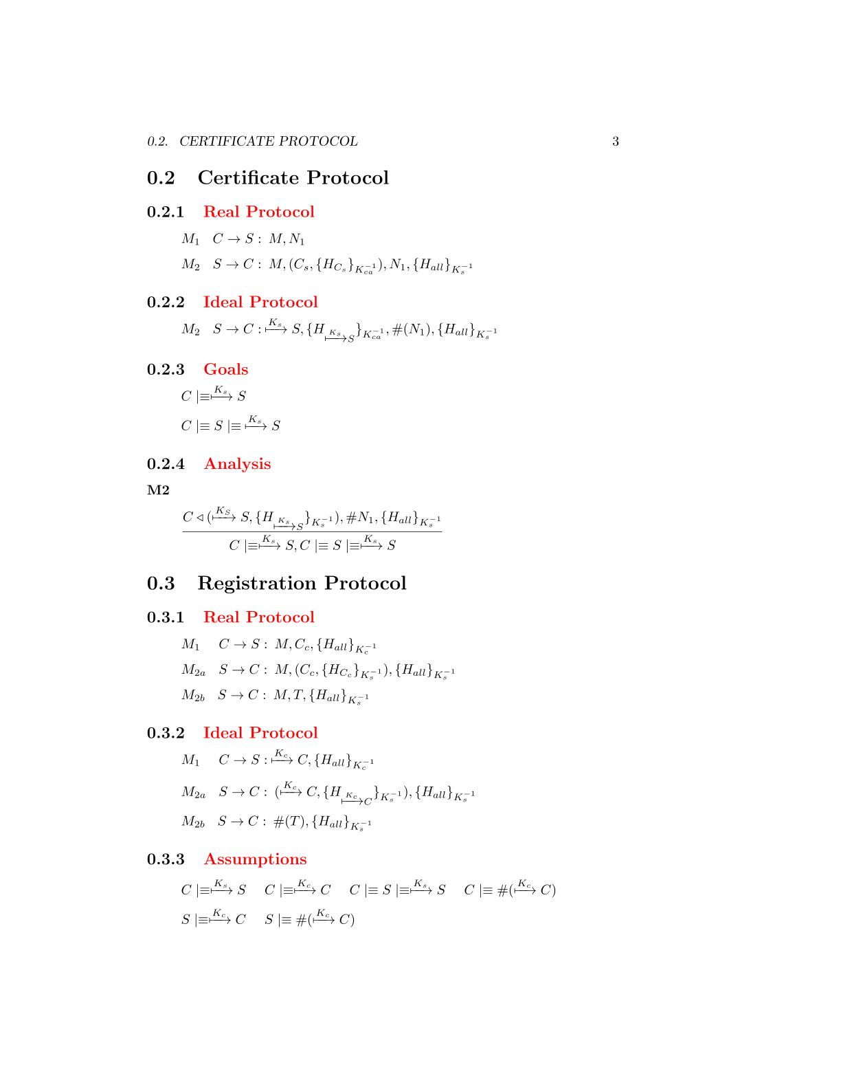

**Real Protocol**

**Ideal Protocol**

**Goals**

**Analysis**



*The client has received the server certificate which is validated by the CA.*

*Moreover the message is fresh due to the nonce field and it contains a signature made by the server RSA private key. We can apply the* ***certificate postulate*** *to derive that the certificate belongs to the server*

M2

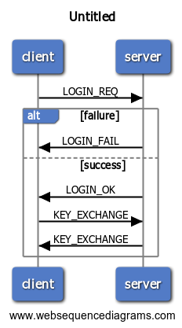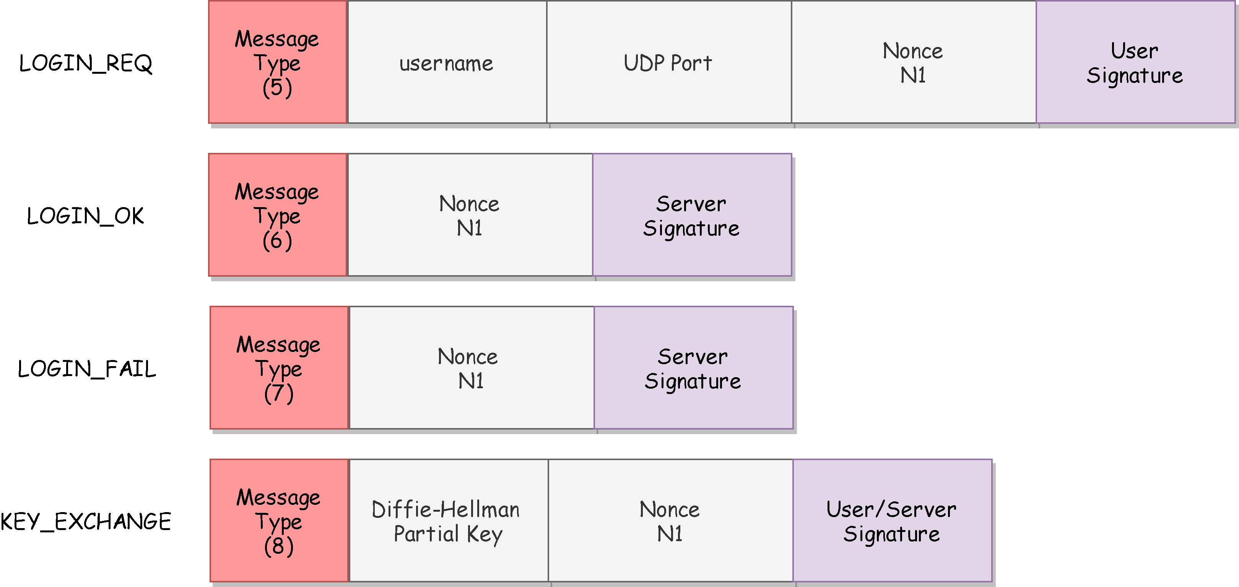The protocol is used by the clients to access to the application. The clients have to give a proof of their authenticity by sending a fresh message containing a signature made by their private RSA key. If the server doesn’t recognize a user the protocol will end with a LOGIN_FAIL message. Otherwise the client and server will proceed with the creation of a session key generated by the Diffie-Hellman key-generation algorithm.

**Login Protocol**

**BAN Logic Analysis**

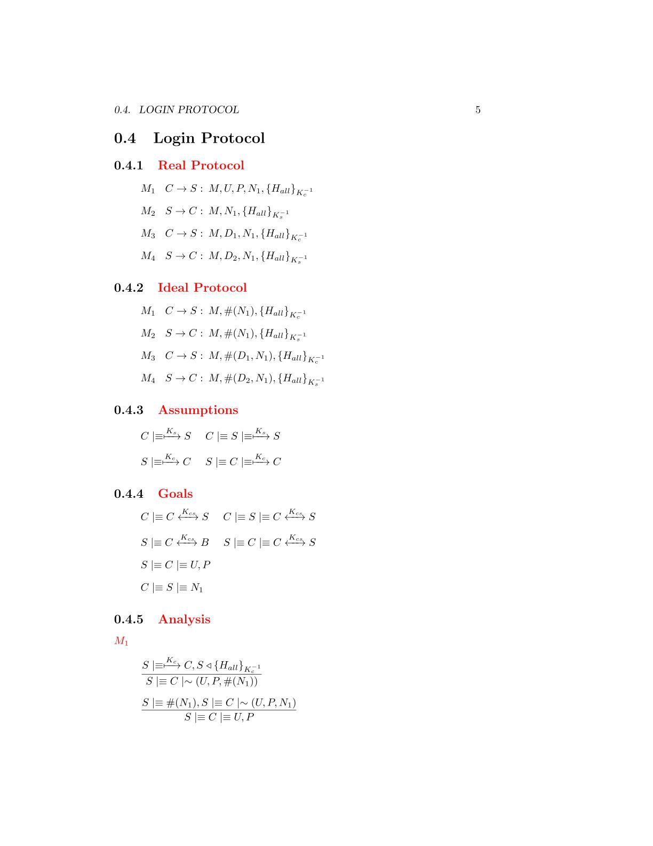

**Assumptions**

**Ideal Protocol**

**Goals**

**Real Protocol**



**Analysis**

*The message contains a fresh field(nonce), so we can apply the* ***nonce verification postulate*** *to derive that the server will believes that only the client could have sent that message*

*The server has received a message containing a signature made by all the fields with the client private RSA key. We can apply the* ***signature postulate*** *to derive that the server will believes that the client has sent the fields of the message*

M1

*The client has received a message containing a signature made by all the fields with the client private RSA key. We can apply the* ***signature postulate*** *to derive that the client will believes that the server has sent the fields of the message*

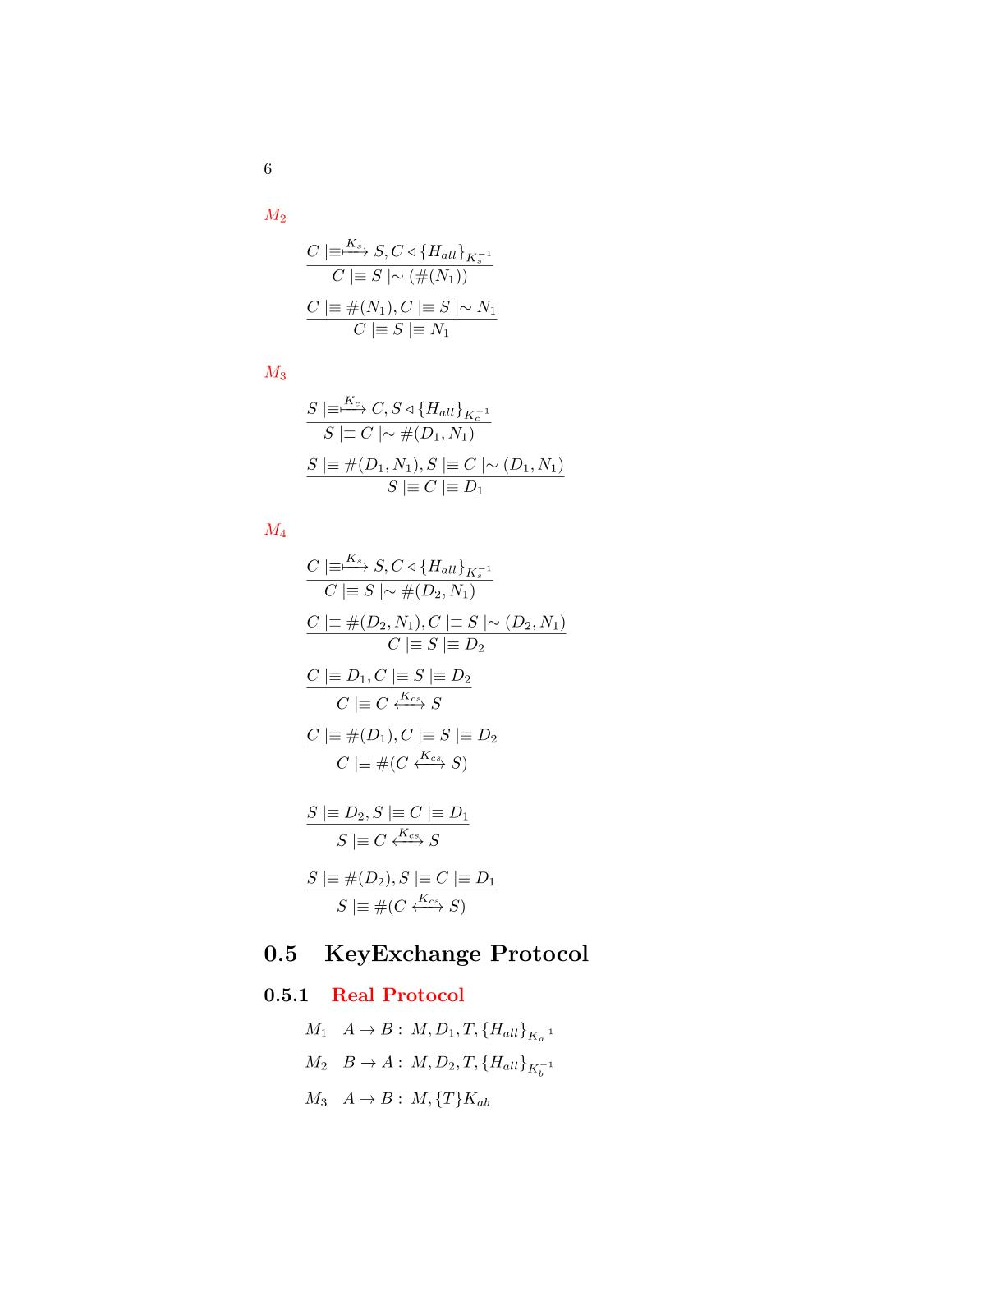

M2



*The message contains a fresh field(nonce), so we can apply the* ***nonce verification postulate*** *to derive that the client will believes that only the server could have sent that message*

M3



*The server has received a message containing a signature made by all the fields with the client private RSA key. We can apply the* ***signature postulate*** *to derive that the server will believes that the client has sent the fields of the message*



*The message contains a fresh field(nonce), so we can apply the* ***nonce verification postulate*** *to derive that the server will believes that only*

*the client could have sent that message*

*The client has received a message containing a signature made by all the fields with the server private RSA key. We can apply the* ***second message meaning postulate*** *to derive that it believes the message is sent by the server*

*The received message contains a field(nonce), so we can apply the* ***nonce verification postulate*** *to derivate that the client believes that only the server could have sent the message*

M4







*We have the two Diffie-Hellman components, we can use the* ***first Diffie-Hellman postulate*** *to derive that the client has generate the shared session key*

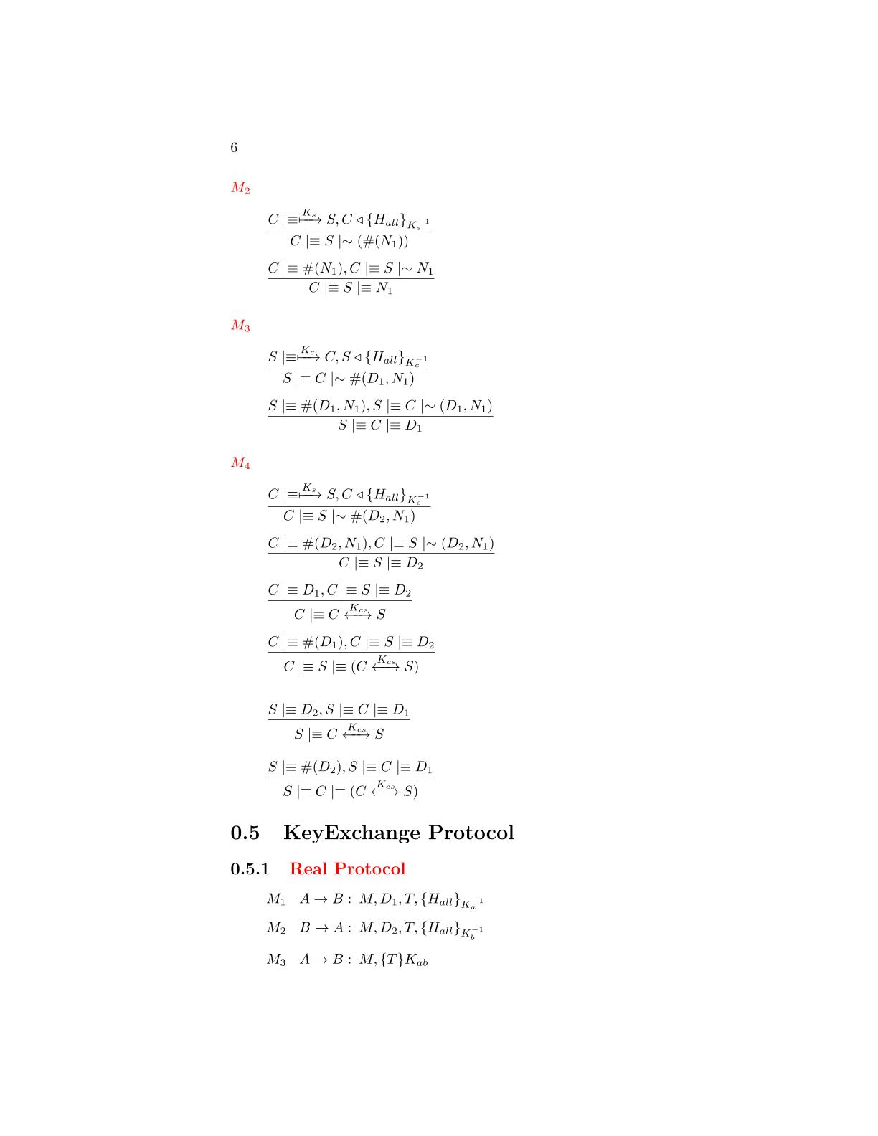

*We have almost one fresh Diffie-Hellman partial key, we can use the* ***second******Diffie-Hellman postulate*** *to derive that the shared key is unique and believing to that session*



*We have the two Diffie-hellman components, we can use the* ***first******Diffie-Hellman postulate*** *to derive that the client has generate the shared session key*



*We have almost one fresh Diffie-Hellman partial key, we can use the* ***second******Diffie-Hellman postulate*** *to derive that the shared key is unique and believing to that session*

# A close up of a sign Description automatically generatedThe protocol will be used by the clients to quit from the application. The messages requires only authenticity and protection to reply attack so they have a signature made by AES-256 GCM based on a fresh nonce.

**Logout Protocol**

**BAN Logic Analysis**

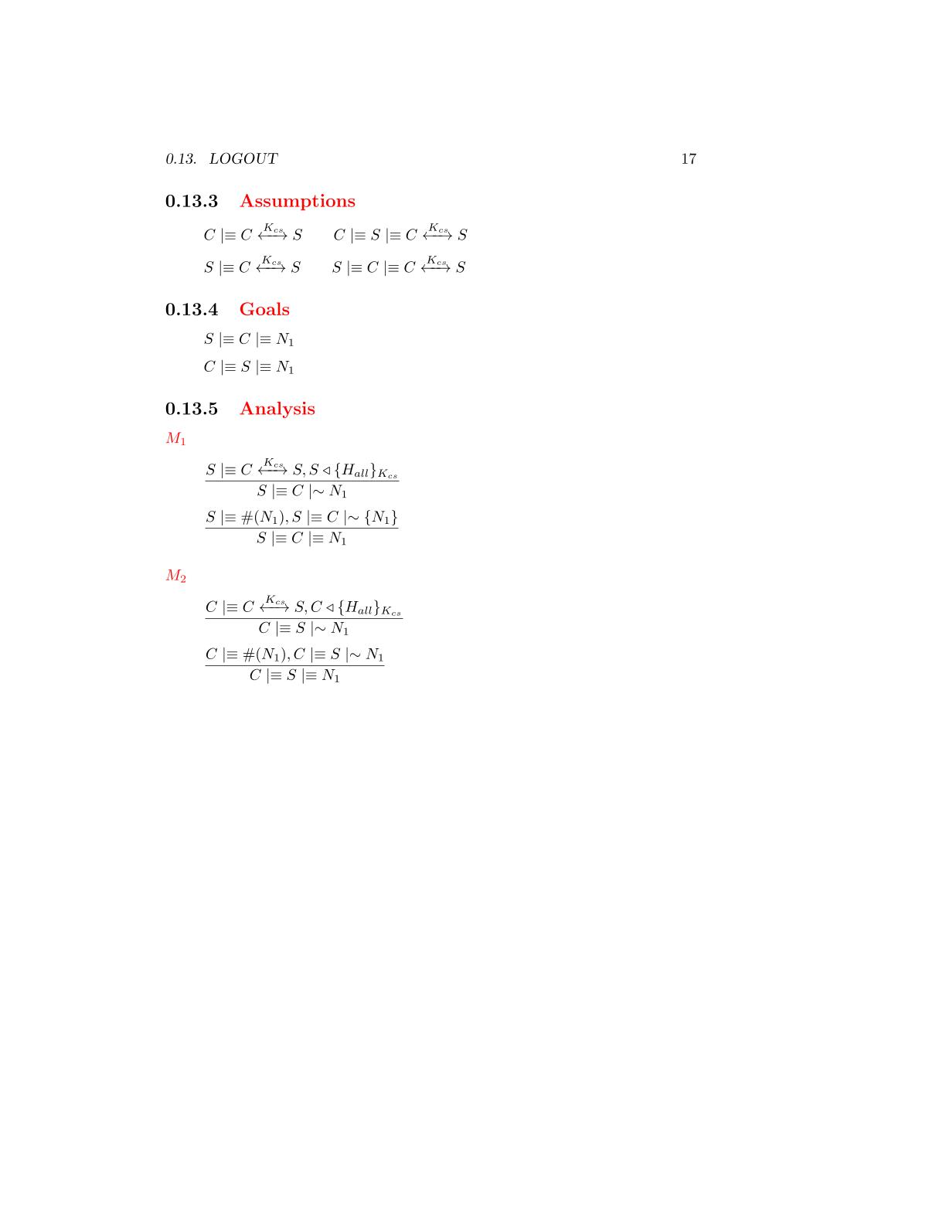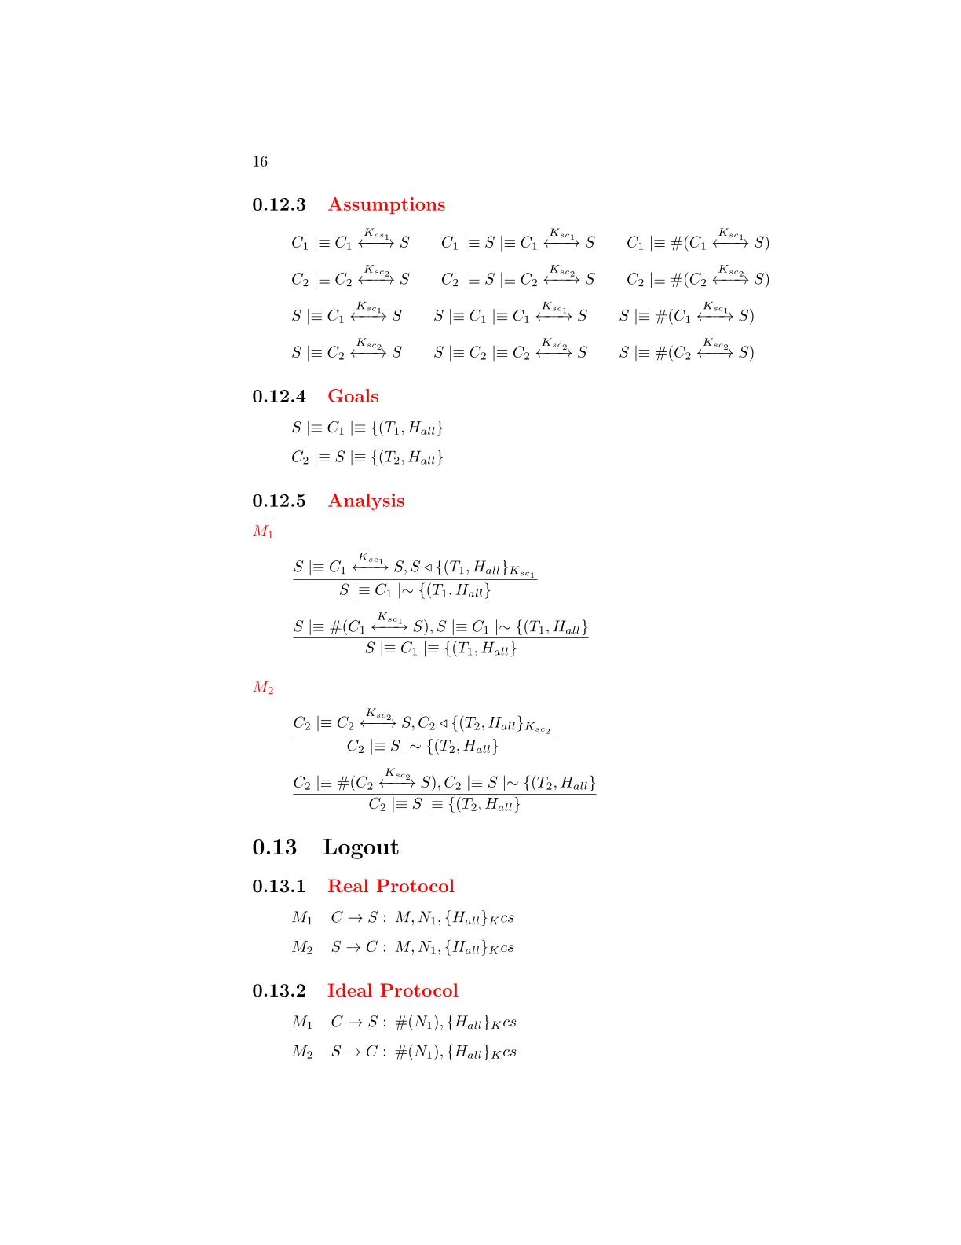

**Ideal Protocol**

**Goals**

**Real Protocol**

**Assumptions**



**Analysis**



*The server has received a message containing a signature made by all the fields with the AES-256 session key. We can apply the* ***signature postulate*** *to derive that the server will believes that the client has sent the fields of the message*

that the server has sent the message

M2

M1



*The message contains a fresh field(nonce), so we can apply the* ***nonce verification postulate*** *to derive that the server will believes that only the client could have sent that message*

that the server has sent the message



*The client has received a message containing a signature made by all the fields with the AES-256 session key. We can apply the* ***signature postulate*** *to derive that the client will believes that the server has sent the fields of the message*

that the server has sent the message



*The message contains a fresh field(nonce), so we can apply the* ***nonce verification postulate*** *to derive that the client will believes that only the server could have sent that message*

# A screenshot of a cell phone Description automatically generatedThe protocol will be used from the clients to obtain a list of the users currently available to be challenged. The user list requires to be confidential and it will be encrypted. All the other fields requires only authentication and will be protected by a signature based on a fresh nonce and made by AES-256 GCM.

**User List Protocol**

**BAN Logic Analysis**

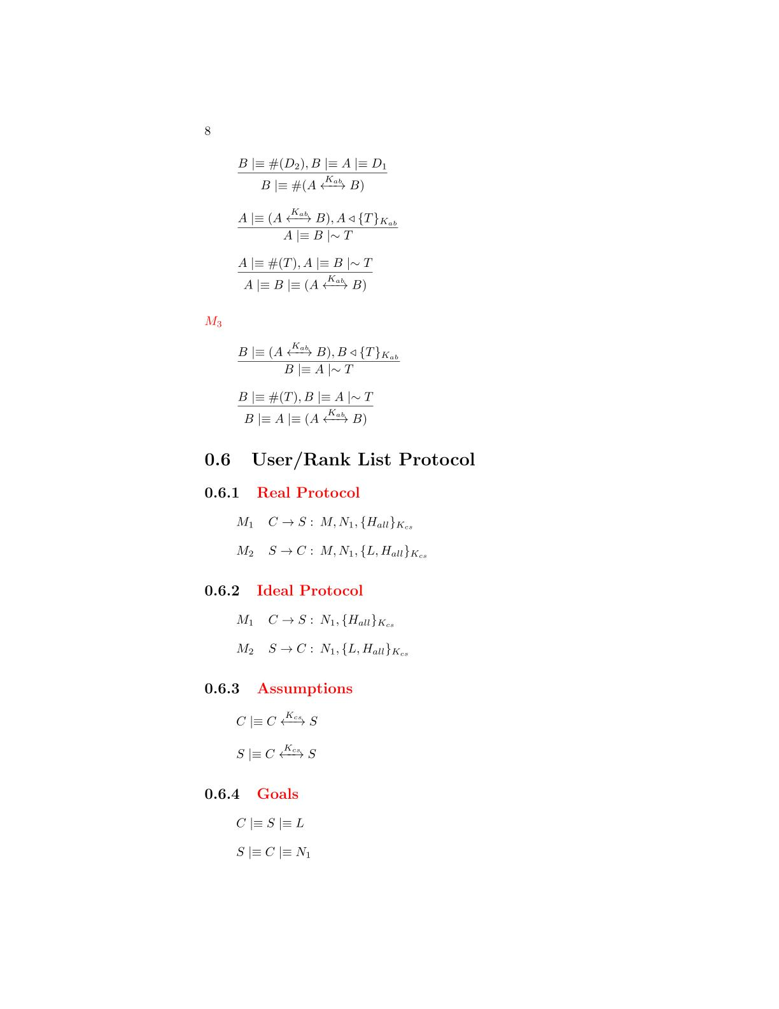

**Goals**

**Ideal Protocol**

**Real Protocol**



**Assumptions**

**Analysis**

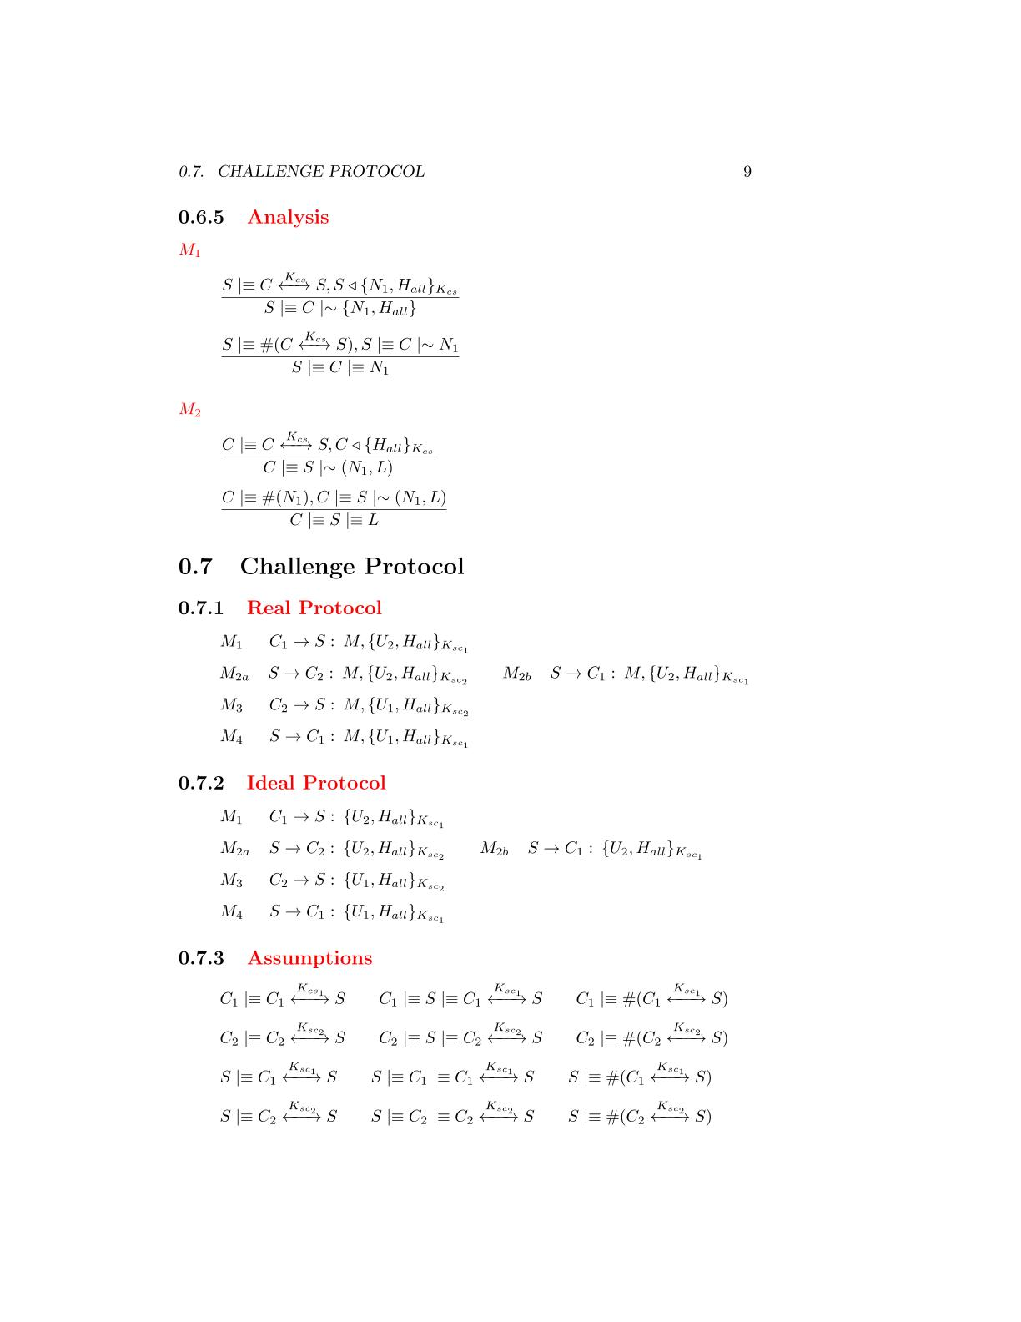

*The server has received a message containing a signature made by all the fields with the AES-256 session key. We can apply the* ***signature postulate*** *to derive that the server will believes that the client has sent the fields of the message*

that the server has sent the message

M2

M1



*The message contains a fresh field(nonce), so we can apply the* ***nonce verification postulate*** *to derive that the server will believes that only the client could have sent that message*

that the server has sent the message



*The client has received a message containing a signature made by all the fields with the AES session key. We can apply the* ***signature postulate*** *to derive that the client will believes that the server has sent the fields of the message*

that the server has sent the message



*The message contains a fresh field(nonce), so we can apply the* ***nonce verification postulate*** *to derive that the client will believes that only the server could have sent that message*

that the server has sent the message

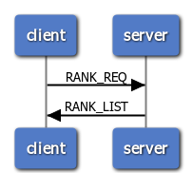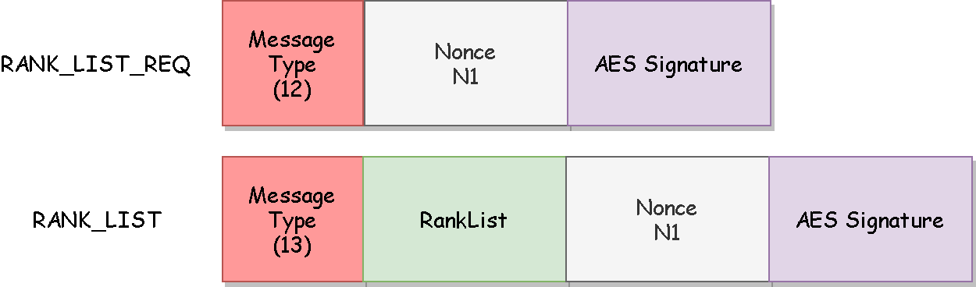The protocol will be used from the clients to obtain a list of the users game statistics. The rank list requires to be confidential and it will be encrypted. All the other fields requires only authentication and they will be protected by a signature based on a fresh nonce and made by AES-256 GCM.

**Rank List Protocol**

**BAN Logic Analysis**



**Goals**

**Ideal Protocol**

**Real Protocol**

**Assumptions**

**Analysis**



*The server has received a message containing a signature made by all the fields with the AES-256 session key. We can apply the* ***signature postulate*** *to derive that the server will believes that the client has sent the fields of the message*

that the server has sent the message

M2

M1



*The message contains a fresh field(nonce), so we can apply the* ***nonce verification postulate*** *to derive that the server will believes that only the client could have sent that message*

that the server has sent the message

*The client has received a message containing a signature made by all the fields with the AES-256 session key. We can apply the* ***signature postulate*** *to derive that the client will believes that the server has sent the fields of the message*

that the server has sent the message





*The message contains a fresh field(nonce), so we can apply the* ***nonce verification postulate*** *to derive that the client will believes that only the server could have sent that message*

that the server has sent the message

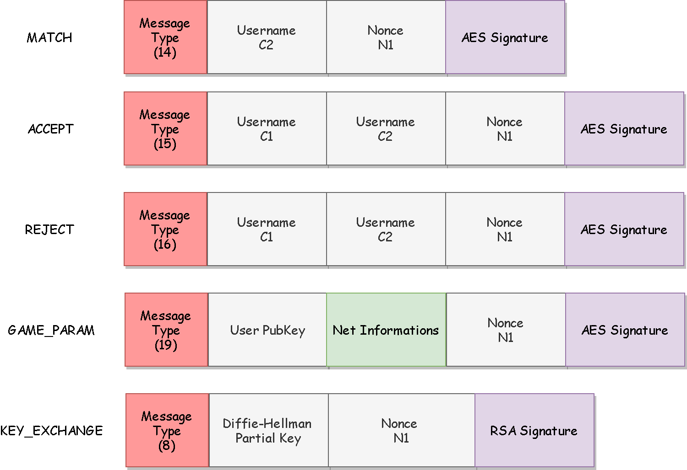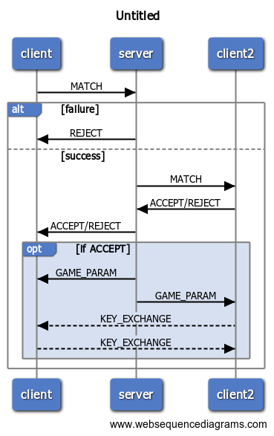The protocol will be used from the clients to request to another player to join a game. The messages requires authenticity so a signature based on a fresh nonce and made by AES-256 GCM is applied on each message. The only fields that require confidentiality are the net information of the users and so they will be encrypted.

**Challenge Protocol**

**BAN Logic Analysis**

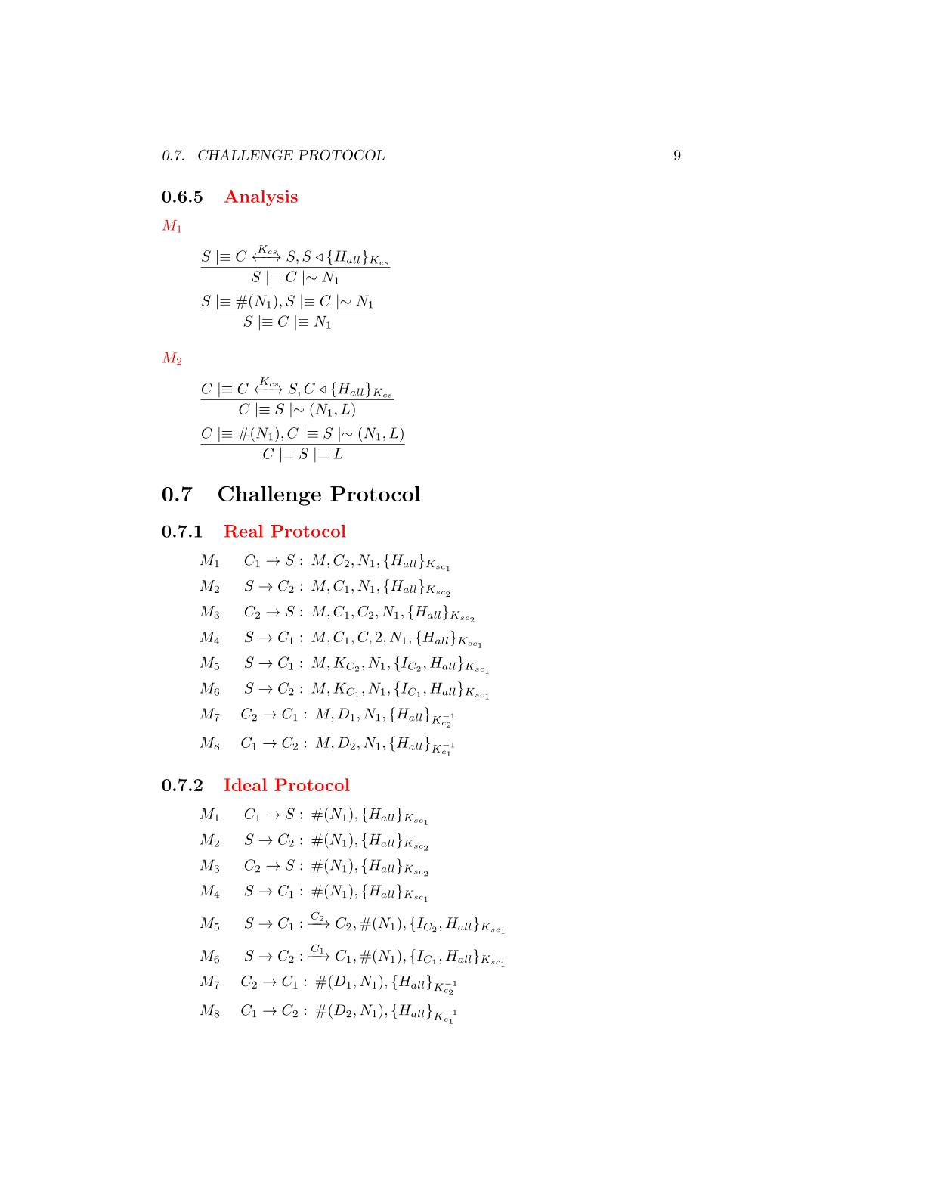

**Real Protocol**

**Goals**

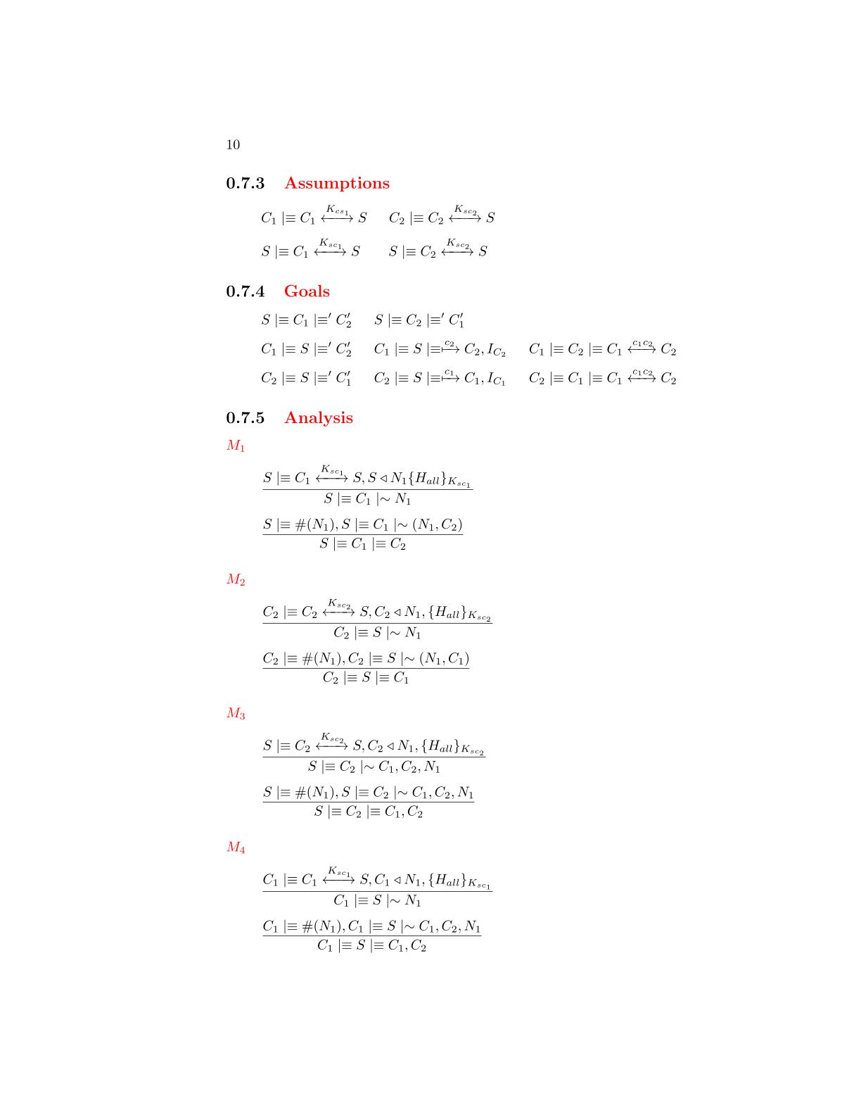



**Assumptions**

**Ideal Protocol**



**Analysis**

M1

M2

M3



*The server has received a message containing a signature made by all the fields with the AES-256 session key. We can apply the* ***signature postulate*** *to derive that the server will believes that the client has sent the fields of the message*

that the server has sent the message

*The message contains a fresh field(nonce), so we can apply the* ***nonce verification postulate*** *to derive that the server will believes that only the client could have sent that message*

that the server has sent the message



*The client has received a message containing a signature made by all the fields with the AES-256 session key. We can apply the* ***signature postulate*** *to derive that the client will believes that the server has sent the fields of the message*

that the server has sent the message





*The message contains a fresh field(nonce), so we can apply the* ***nonce verification postulate*** *to derive that the client will believes that only the server could have sent that message*

that the server has sent the message

*The server has received a message containing a signature made by all the fields with the AES-256 session key. We can apply the* ***signature postulate*** *to derive that the server will believes that the client has sent the fields of the message*

that the server has sent the message





*The message contains a fresh field(nonce), so we can apply the* ***nonce verification postulate*** *to derive that the server will believes that only the client could have sent that message*

that the server has sent the message

M4



*The client has received a message containing a signature made by all the fields with the AES-256 session key. We can apply the* ***signature postulate*** *to derive that the client will believes that the server has sent the fields of the message*

that the server has sent the message



*The message contains a fresh field(nonce), so we can apply the* ***nonce verification postulate*** *to derive that the client will believes that only the server could have sent that message*

that the server has sent the message

*The client has received a message containing a signature made by all the fields with the AES-256 session key. We can apply the* ***signature postulate*** *to derive that the client will believes that the server has sent the fields of the message*

that the server has sent the message

M5

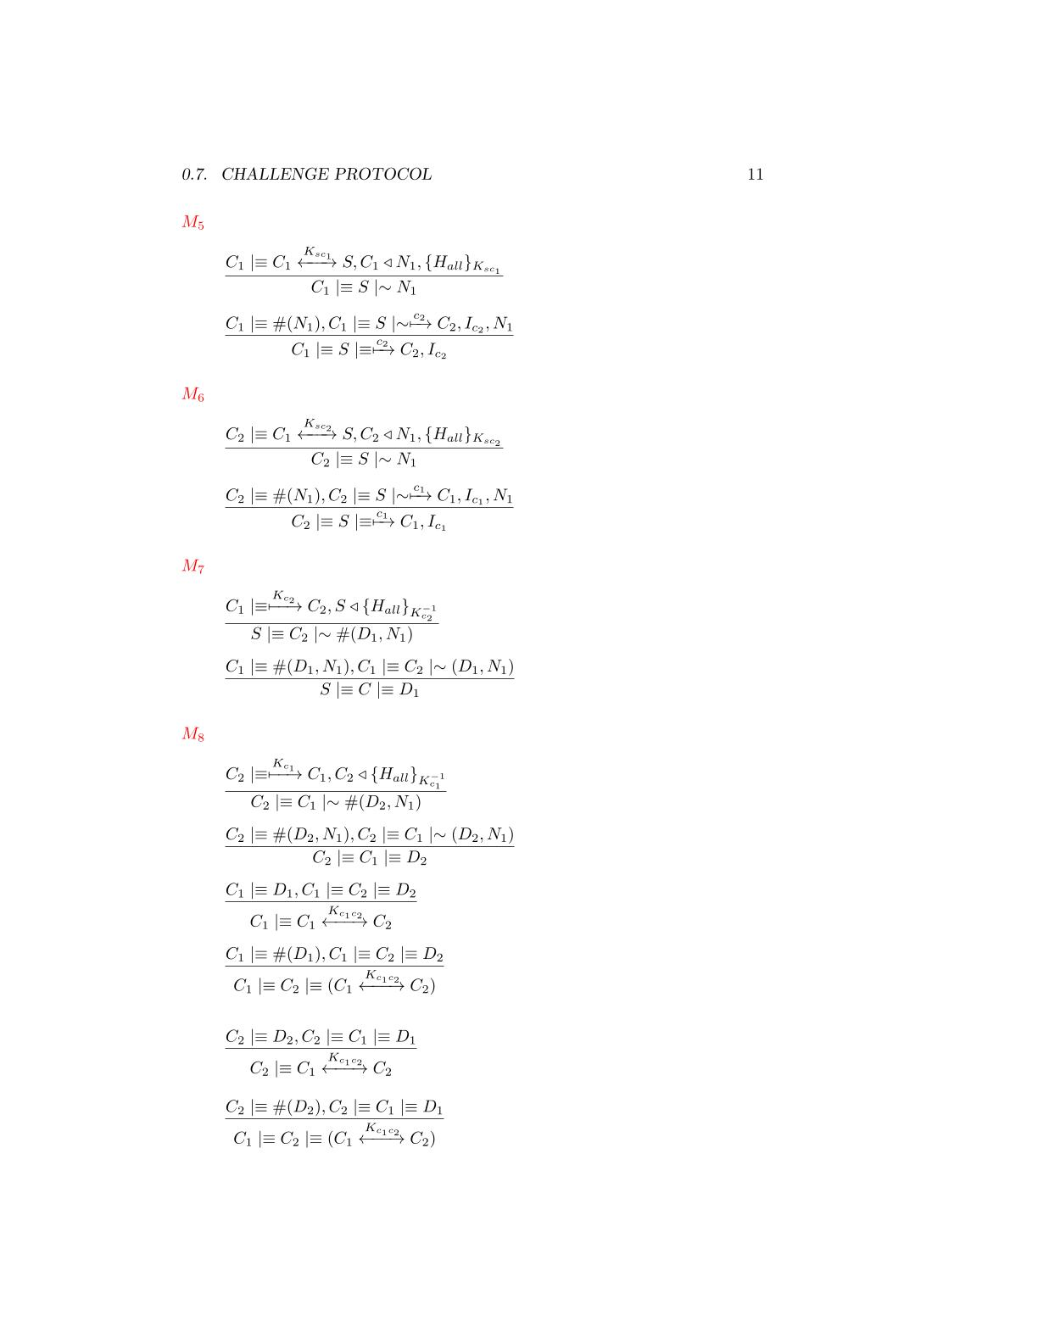



*The message contains a fresh field(nonce), so we can apply the* ***nonce verification postulate*** *to derive that the client will believes that only the server could have sent that message*

that the server has sent the message

*The client has received a message containing a signature made by all the fields with the AES-256 session key. We can apply the* ***signature postulate*** *to derive that the client will believes that the server has sent the fields of the message*

that the server has sent the message

M6





*The message contains a fresh field(nonce), so we can apply the* ***nonce verification postulate*** *to derive that the client will believes that only the server could have sent that message*

that the server has sent the message



*The client has received a message containing a signature made by all the fields with the client RSA private key. We can apply the* ***signature postulate*** *to derive that the client will believes that the other client has sent the fields of the message*

that the server has sent the message

*The message contains a fresh field(nonce), so we can apply the* ***nonce verification postulate*** *to derive that the client will believes that only the other client could have sent that message*

that the server has sent the message

M7



M8



*The client has received a message containing a signature made by all the fields with the client RSA private key. We can apply the* ***signature postulate*** *to derive that the client will believes that the other client has sent the fields of the message*

that the server has sent the message

*The message contains a fresh field(nonce), so we can apply the* ***nonce verification postulate*** *to derive that the client will believes that only the other client could have sent that message*

that the server has sent the message





*We have almost one fresh Diffie-Hellman partial key, we can use the second* ***Diffie-Hellman postulate*** *to derive that the shared key is unique and believing to that session*

*We have the two Diffie-Hellman components, we can use the first* ***Diffie-Hellman postulate*** *to derive that the client has generate the shared session key*

*We have almost one fresh Diffie-Hellman partial key, we can use the second* ***Diffie-Hellman postulate*** *to derive that the shared key is unique and believing to that session*

*We have the two Diffie-Hellman components, we can use the first* ***Diffie-Hellman postulate*** *to derive that the client has generate the shared session key*







# A close up of a sign Description automatically generatedThe protocol will be used from the clients to undo a previously sent challenge. The messages requires authenticity so a signature based on a fresh nonce and made by AES-256 GCM is applied on each message.

**Withdraw Protocol**

**BAN Logic Analysis**

**Real Protocol**

**Ideal Protocol**

**Goals**

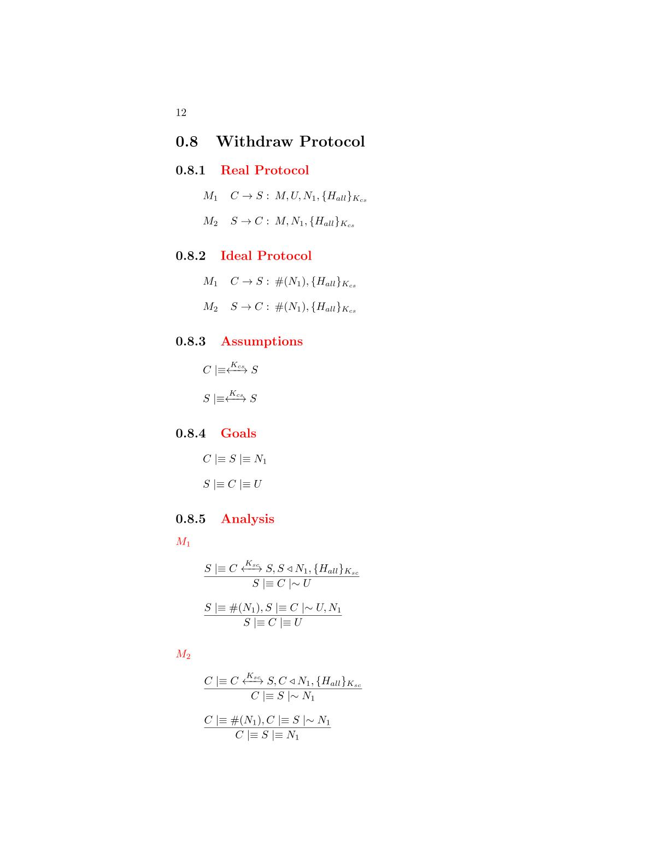

**Assumptions**



**Analysis**

*The server has received a message containing a signature made by all the fields with the AES-256 session key. We can apply the* ***signature postulate*** *to derive that the server will believes that the client has sent the fields of the message*

that the server has sent the message

M2

M1





*The message contains a fresh field(nonce), so we can apply the* ***nonce verification postulate*** *to derive that the server will believes that only the client could have sent that message*

that the server has sent the message



*The client has received a message containing a signature made by all the fields with the AES-256 session key. We can apply the* ***signature postulate*** *to derive that the client will believes that the server has sent the fields of the message*

that the server has sent the message

*The message contains a fresh field(nonce), so we can apply the* ***nonce verification postulate*** *to derive that the client will believes that only the server could have sent that message*

that the server has sent the message



# The protocol will be used from the clients to make a move during the match. The messages requires authenticity so a signature based on a fresh nonce and made by AES-256 GCM is applied on each message. The only field that requires confidentiality is the chosen column of the user and so it will be encrypted*.*

**Move Protocol**

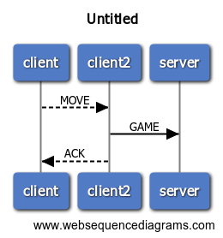

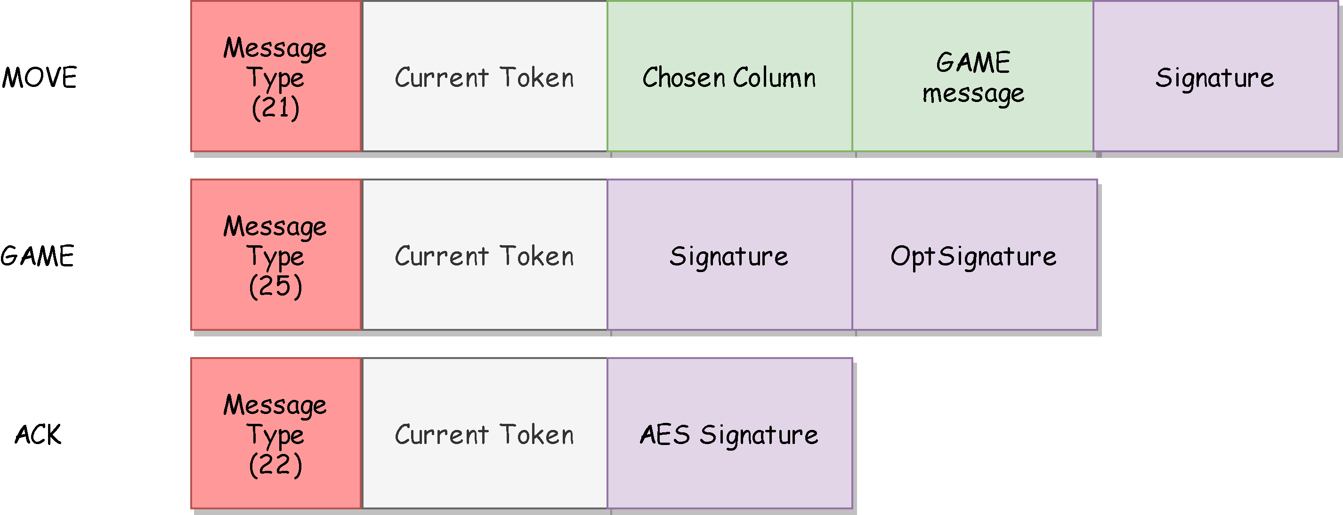

**BAN Logic Analysis**

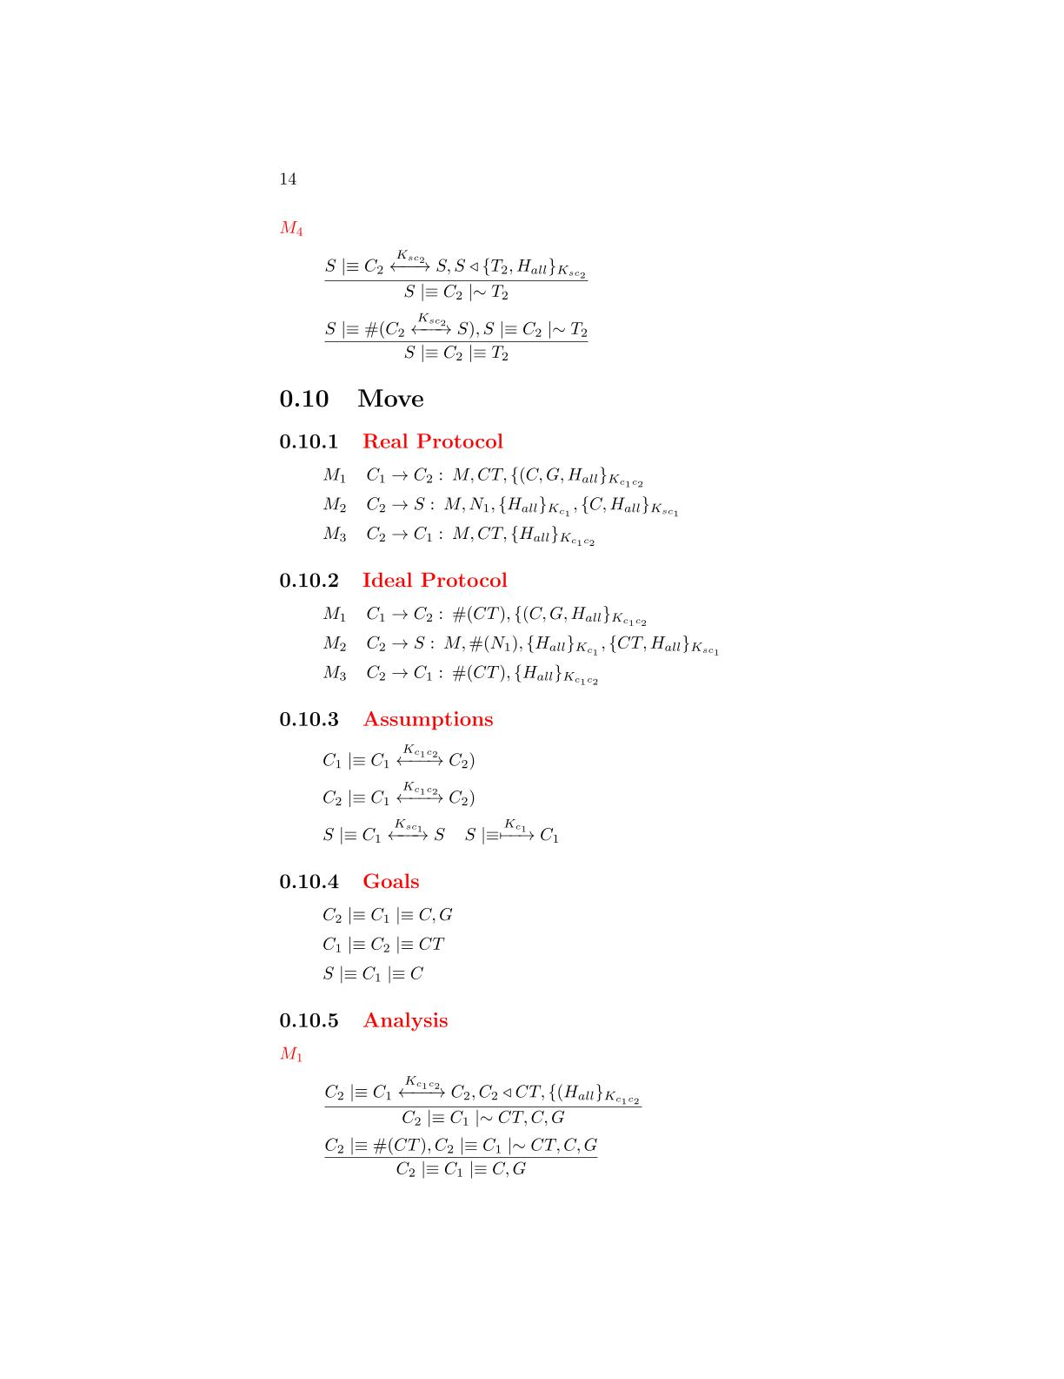

**Real Protocol**

**Goals**



**Ideal Protocol**

**Assumptions**



**Analysis**

M1



*The client has received a message containing a signature made by all the fields with the AES-256 session key. We can apply the* ***signature postulate*** *to derive that the client will believes that the other client has sent the fields of the message*

*The message contains a fresh field(nonce), so we can apply the* ***nonce verification postulate*** *to derive that the client will believes that only the other client could have sent that message*

that the server has sent the message



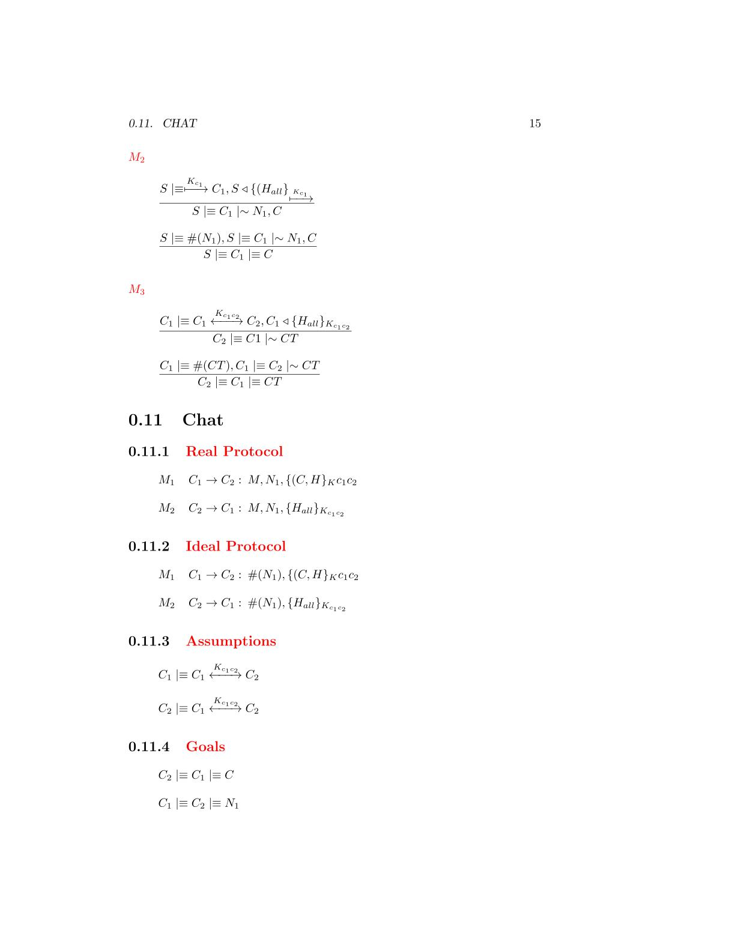

*The client has received a message containing a signature made by all the fields with the AES-256 session key. We can apply the* ***signature postulate*** *to derive that the client will believes that the other client has sent the fields of the message*

that the server has

M2



*The message contains a fresh field(nonce), so we can apply the* ***nonce verification postulate*** *to derive that the client will believes that only the other client could have sent that message*

that the server has sent the message

*The client has received a message containing a signature made by all the fields with the AES-256 session key. We can apply the* ***signature postulate*** *to derive that the client will believes that the other client has sent the fields of the message*



M3

*The message contains a fresh field(nonce), so we can apply the* ***nonce verification postulate*** *to derive that the client will believes that only the other client could have sent that message*

that the server has sent the message



**Chat Protocol**

# The protocol will be used from the clients to send a message the adversary during the match. The messages requires authenticity so a signature based on a fresh nonce and made by AES-256 GCM is applied on each message. The only field that requires confidentiality is the sent message and so it will be encrypted.

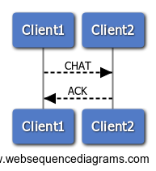

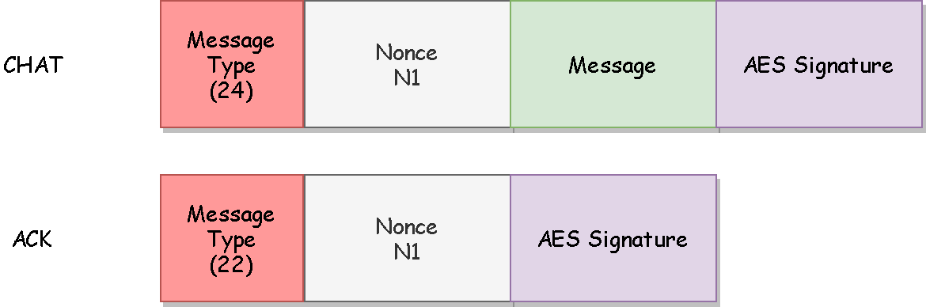

**BAN Logic Analysis**

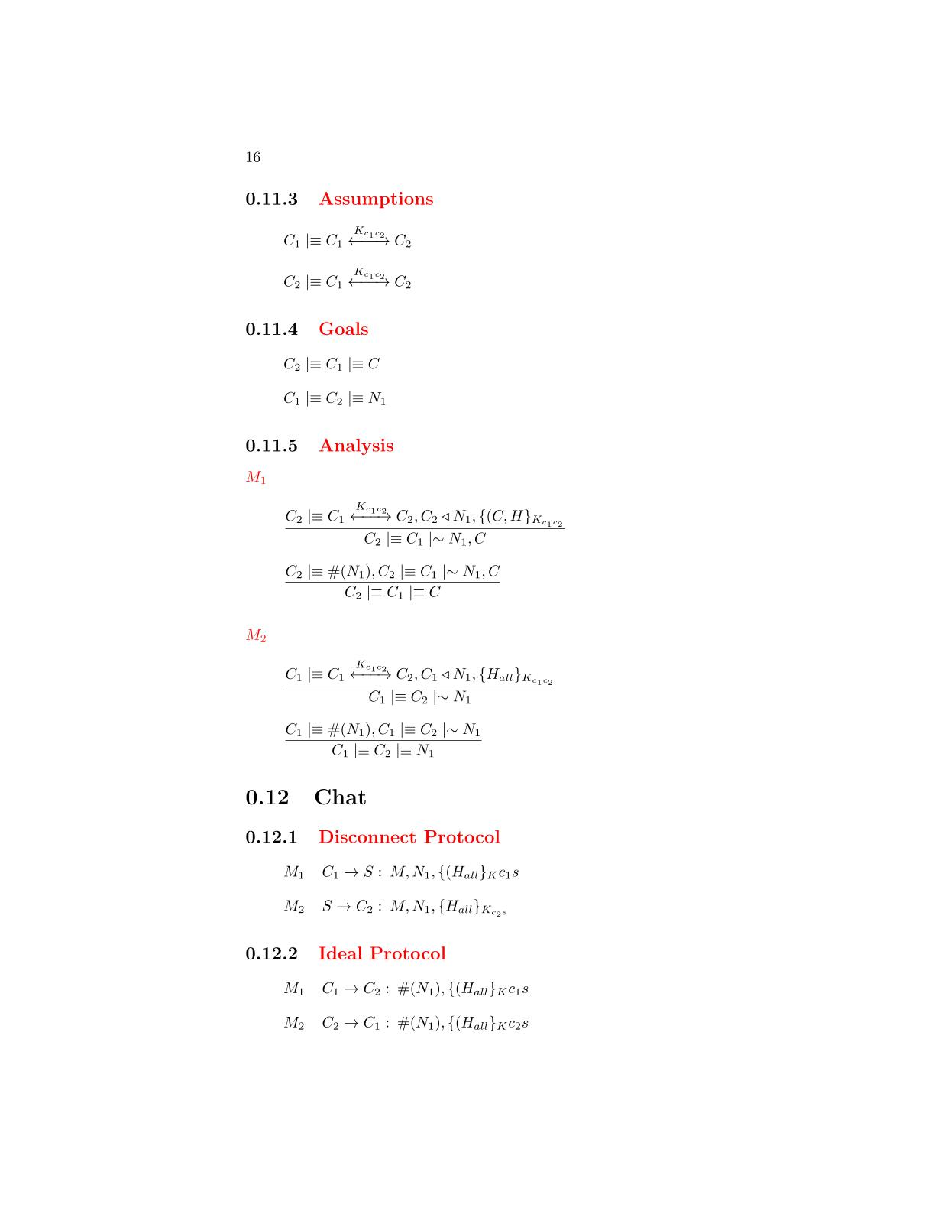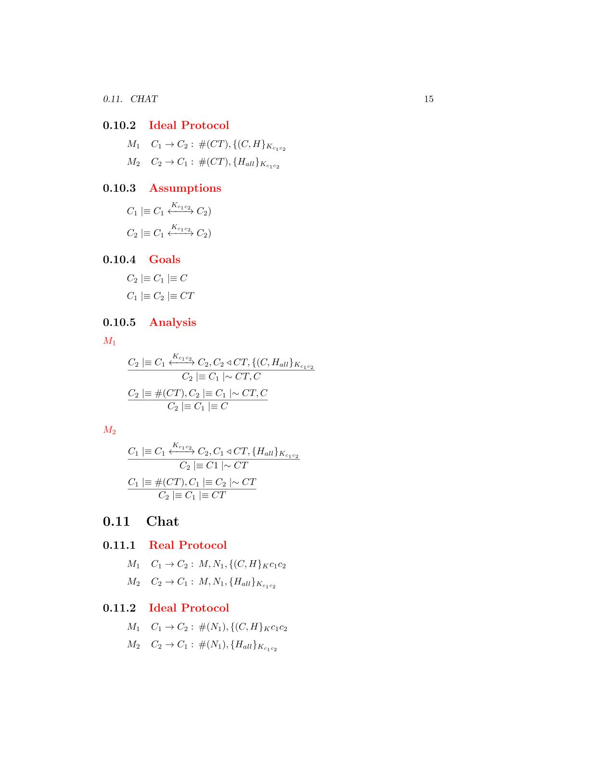

**Ideal Protocol**

**Real Protocol**

**Goals**

**Assumptions**



**Analysis**



*The client has received a message containing a signature made by all the fields with the AES-256 session key. We can apply the* ***signature postulate*** *to derive that the client will believes that the other client has sent the fields of the message*

M1

*The message contains a fresh field(nonce), so we can apply the* ***nonce verification postulate*** *to derive that the client will believes that only the other client could have sent that message*

that the server has sent the message



M2

*The client has received a message containing a signature made by all the fields with the AES-256 session key. We can apply the* ***signature postulate*** *to derive that the client will believes that the other client has sent the fields of the message*



*The message contains a fresh field(nonce), so we can apply the* ***nonce verification postulate*** *to derive that the client will believes that only the other client could have sent that message*

that the server has sent the message



*The message contains a fresh field(nonce), so we can apply the* ***nonce verification postulate*** *to derive that the client will believes that only the other client could have sent that message*

that the server has sent the message

*The client has received a message containing a signature made by all the fields with the AES-256 session key. We can apply the* ***signature postulate*** *to derive that the client will believes that the other client has sent the fields of the message*

M3

**Disconnect Protocol**

# The protocol will be used from the clients to exit from a match. The messages requires authenticity so a signature based on a fresh nonce and made by AES-256 GCM is applied on each message.

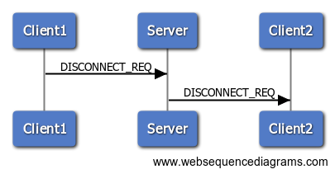

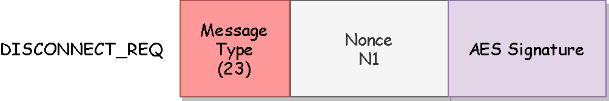

**BAN Logic Analysis**

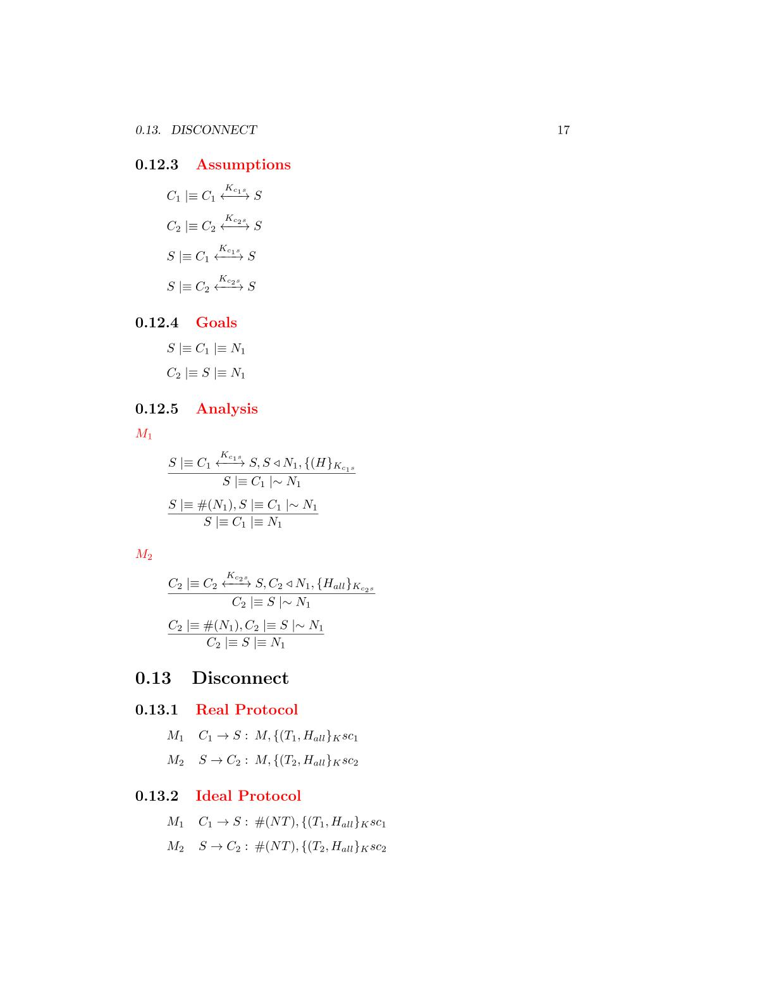

**Ideal Protocol**

**Real Protocol**

**Goals**

**Assumptions**



**Analysis**

M1

M2



*The server has received a message containing a signature made by all the fields with the AES-256 session key. We can apply the* ***signature postulate*** *to derive that the server will believes that the client has sent the fields of the message*

that the server has sent the message

*The message contains a fresh field(nonce), so we can apply the* ***nonce verification postulate*** *to derive that the server will believes that only the client could have sent that message*

that the server has sent the message



*The client has received a message containing a signature made by all the fields with the AES-256 session key. We can apply the* ***signature postulate*** *to derive that the client will believes that the server has sent the fields of the message*

that the server has sent the message





*The message contains a fresh field(nonce), so we can apply the* ***nonce verification postulate*** *to derive that the client will believes that only the server could have sent that message*

that the server has sent the message

Software Architecture

# The following section will describe the client and server implementation. The application is created with the C ++ language using OpenSSL and MySQL libraries to create the encryption components and the interface to a remote database granted free of charge by the ***myremotesql.com*** site.

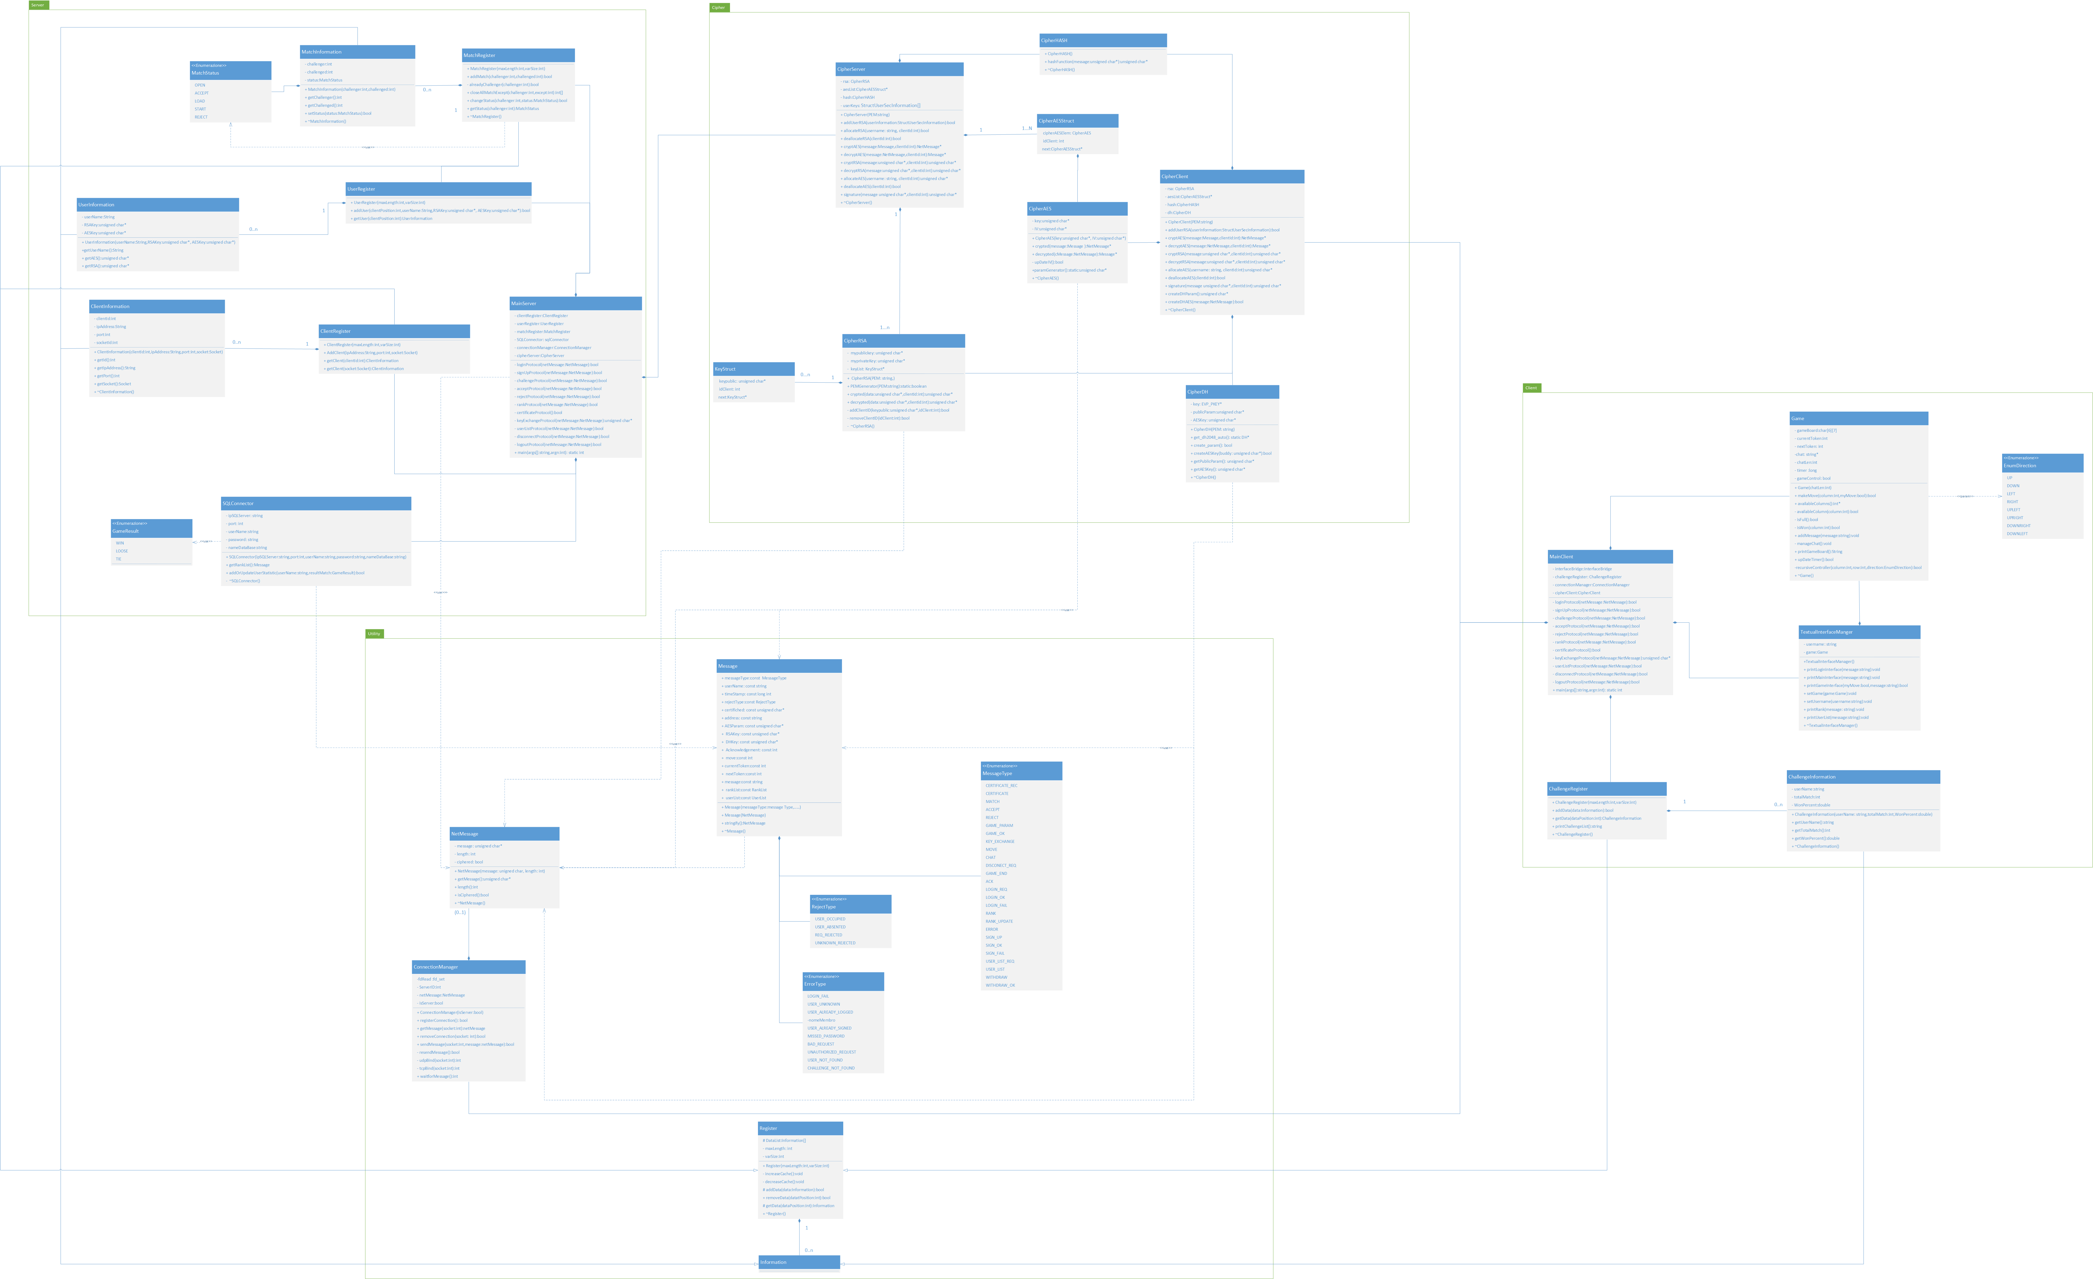

# The server is built above **ConnectionManager**, the class is in charge of receiving and sending messages over the network. The behavior of the service is implemented through a set of callback functions developed to manage the requests used by the service(**MainServer** class).

**Server**

# To manage requests, the callback functions rely on three different classes:

# **CipherServer**: the class provides methods to encrypt and decrypt messages by AES-256 GCM, make and verify signatures both by AES-256 GCM and RSA, and generate random values.

# **MysqlConnector**, provides an interface to query a remote database to take or update information about users’ranking

# **Registers**, a set of three classes (**ClientRegister**, **UserRegister** and **MatchRegister**) to manage the information of users registered to the service and their relationships

**Client**

User Manual